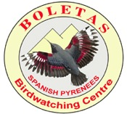
Birdwatching Holidays in Spain, Morocco & more…

BOLETAS Birdwatching centre
22192 Loporzano (Huesca) – Spain
tel/fax 00 34 974 262027 or 01162 889318
e.mail: jjsv@boletas.org // www.boletas.org
Esther Diago Millán - NIF 38493051K

Boletas Siri Lanka Tour

TOUR  Siri Lanka | DATES  November 22nd to 4th April 2017

Party: Ken Charity, Tracey Charity ,Alan Woodward ,Sandra Woodward, Roger Theobald
Imogen Theobald, Debbie Easterwood, Mark Easterwood, Andy Rhodes, Alison Rhodes

Tour Leader : Josele J Saiz & Local guides

Total Number of Bird Species : 229

Weather & Sites:
Day 1 –  22.11.17 | Humid, storms 30º  Olombo airport- Kitulgala
Day2 –  23.11.17 | Sunny but humid 29º  Kitungala police station
Day 3 –  24.11.17 | Pleasant, cloudy 26º  From kitungala to Nuwaraeñiya and Victiria Park
Day 4  25.11.17 | Raining 26º  Horton Plains and Victoria Park
Day 5 –  26.11.17 | Rainy, cloudy and humid 21º  Surrey state, Tissamaraharama Wetlaands
Day 6 –  27.11.17 | Rainy and wet 21º  Yala National Park
Day 7 –  28.11.17 | Rainy and cloudy 23º  Bundala National Park – Centuria lake
Day 8 –  29.11.17 | Rainy and wet 23º  Udawalawa - Sinharaja
Day 9 –  30.11.17 | Rainy and wet 24º  Sinharaja National Park
Day 10-  1.12.17 | Rainy, cloudy, and some Sun – 25º  Sinharaja National Park to Mirissa
Day 11-  2.11.17 | Rainy, cloudy but sunny29º  Mirissa
Day 12-  3.12.17 | Nice and warm 30º  Mirissa
Day 13-  4.11.17 | Nice , sunny some storms 27º  Mirissa

Favourite bird of the tour

Ken Charity – India Pita
Tracey Charity - Forest Wagtail
Alan Woodward - Brown Capped Babbler
Sandra Woodward – Sri Lanka Frogmouth
Roger Theobald- Indian Pita
Imogen Theobald- Sri Lanka Frogmouth
Mark Easterbrook- Chesnut headed Bee-Eater
Debbie Easterbrook - Chesnut headed Bee-Eater A
ndy Rhodes- Sri Lanka Bush Warbler
Alison RHodes - India Pita
Josele- Siri Lanka Simitar Babbler
Titran- Serendib Spos Owl

SIRI LANKA FIELD CHECK LIST

Abundant (+++) Common (++) Rare (+) Juvenile (Juv) Immature (Inm) Adult (Ad) Female Male

English name | Scientific name |  | 21 | 22 | 23 | 24 | 25 | 26 | 27 | 28 | 29 | 30 | 1 | 2 | 3 | 4
Lesser Whistling-Duck | Dendrocygna javanica |  |  |  |  |  |  | x | x |  | x |  |  | x
Cotton Pygmy-Goose | Nettapus coromandelianus |  |  |  |  |  | x
Indian Peafowl | Pavo cristatus |  |  |  |  |  | x | x | x | x
Sri Lanka Spurfowl | Galloperdix bicalcarata |  |  | h |  |  | x | x | x | x | x |  | x
Sri Lanka Junglefowl | Gallus lafayettii |  |  |  |  | x |  | x | x |  | x | x | h
Little Grebe | Tachybaptus ruficollis |  |  |  |  |  |  |  |  |  | x
Asian Openbill | Anastomus oscitans |  | x | x | x |  | x | x | x | x |  |  | x
Woolly-necked Stork | Ciconia episcopus |  |  | x |  |  |  | x | x
Black-necked Stork | Ephippiorhynchus asiaticus |  |  |  |  |  |  |  | x
Lesser Adjutant | Leptoptilos javanicus |  |  |  |  |  |  |  | x |  | x
Painted Stork | Mycteria leucocephala |  |  |  |  |  |  |  |  | x | x
Little Cormorant | Microcarbo niger |  | x | x |  | x |  |  |  |  |  |  | x
Indian Cormorant | Phalacrocorax fuscicollis |  | x |  |  |  | x | x | x | x |  |  | x
Oriental Darter | Anhinga melanogaster |  |  |  |  |  | x
Spot-billed Pelican | Pelecanus philippensis |  |  |  |  |  | x | x | x | x |  |  | x
Yellow Bittern | Ixobrychus sinensis |  |  |  |  |  | x |  | x |  |  |  | x
Black Bittern | Ixobrychus flavicollis |  |  |  |  |  | x
Gray Heron | Ardea cinerea |  | x |  |  | x | x | x | x | x |  |  | x
Purple Heron | Ardea purpurea |  |  |  |  |  | x | x | x |  |  |  |  | x
Great Egret | Ardea alba |  | x |  |  |  |  | x | x | x |  |  |  | x
Intermediate Egret | Ardea intermedia |  | x |  |  |  |  | x | x | x |  |  |  | x
Little Egret | Egretta garzetta |  | x |  |  |  |  | x | x | x |  |  |  | x
Cattle Egret | Bubulcus ibis |  | x |  | x | x | x | x | x | x
Indian Pond-Heron | Ardeola grayii |  | x |  | x | x | x | x | x | x |  |  | x
Striated Heron | Butorides striata |  |  |  |  |  |  |  |  |  |  |  | x | x
Black-headed Ibis | Threskiornis melanocephalus |  |  |  |  |  | x | x | x | x
Eurasian Spoonbill | Platalea leucorodia |  |  |  |  |  |  | x | x
English name | Scientific name |  | 21 | 22 | 23 | 24 | 25 | 26 | 27 | 28 | 29 | 30 | 1 | 2 | 3 | 4
Black-shouldered Kite | Elanus caeruleus |  |  |  |  | x
Crested Serpent-Eagle | Spilornis cheela |  |  | x | x |  |  | x | x | x |  | x | x
Crested Hawk-Eagle | Nisaetus cirrhatus |  |  |  |  |  |  | x | x | x
Legge's Hawk-Eagle | Nisaetus kelaarti |  |  |  |  |  |  |  |  |  | x
Black Eagle | Ictinaetus malaiensisz |  |  | x
Shikra | Accipiter badius |  |  |  |  |  |  | x | x | x
Brahminy Kite | Haliastur indus |  | x |  |  |  | x | x | x | x |  |  | x |  | x
White-bellied Sea-Eagle | Haliaeetus leucogaster |  |  | x | x |  | x | x | x | x
Gray-headed Fish-Eagle | Haliaeetus ichthyaetus |  |  |  |  |  |  |  |  |  |  |  | x | x
Slaty-legged Crake | Rallina eurizonoides |  |  |  |  |  |  |  |  |  |  | x
White-breasted Waterhen | Amaurornis phoenicurus |  | x |  | x |  | x | x | x | x | x | x | x
Watercock | Gallicrex cinerea |  |  |  |  |  |  |  |  | x |  |  |  | x
Gray-headed Swamphen | Porphyrio poliocephalus |  |  |  |  |  |  | x | x | x |  |  |  | x
Eurasian Moorhen | Gallinula chloropus |  |  |  |  |  |  | x |  | x |  |  |  | x
Indian Thick-knee | Burhinus indicus |  |  |  |  |  |  |  |  | x
Great Thick-knee | Esacus recurvirostris |  |  |  |  |  |  |  | x | x
Black-winged Stilt | Himantopus himantopus |  | x |  |  |  | x | x | x
Black-bellied Plover | Pluvialis squatarola |  |  |  |  |  |  |  | x
Pacific Golden-Plover | Pluvialis fulva |  |  |  |  |  |  | x | x
Yellow-wattled Lapwing | Vanellus malabaricus |  |  |  |  |  |  | x | x
Red-wattled Lapwing | Vanellus indicus |  | x |  |  |  | x | x | x | x |  |  | x
Sociable Lapwing | Vanellus gregarius |  |  |  |  |  |  | x
Lesser Sand-Plover | Charadrius mongolus |  |  |  |  |  |  | x | x
Kentish Plover | Charadrius alexandrinus |  |  |  |  |  |  | x | x
Common Ringed Plover | Charadrius hiaticula |  |  |  |  |  |  | x | x
Little Ringed Plover | Charadrius dubius |  |  |  |  |  |  | x | x
Pheasant-tailed Jacana | Hydrophasianus chirurgus |  |  |  |  |  | x | x | x |  |  |  | x
Black-tailed Godwit | Limosa limosa |  |  |  |  |  |  |  | x
Ruddy Turnstone | Arenaria interpres
Broad-billed Sandpiper | Calidris falcinellus |  |  |  |  |  |  | x | x
Temminck's Stint | Calidris temminckii |  |  |  |  |  |  | x
Little Stint | Calidris minuta |  |  |  |  |  |  |  | x
Common Snipe | Gallinago gallinago |  |  |  |  |  |  | x
English name | Scientific name |  | 21 | 22 | 23 | 24 | 25 | 26 | 27 | 28 | 29 | 30 | 1 | 2 | 3 | 4
Pin-tailed Snipe | Gallinago stenura |  |  |  |  |  |  | x |  |  |  |  | x
Common Sandpiper | Actitis hypoleucos |  | x |  | x | x | x | x | x | x
Green Sandpiper | Tringa ochropus |  |  |  |  |  |  | x | x | x
Spotted Redshank | Tringa erythropus |  |  |  |  |  |  | x | x
Common Greenshank | Tringa nebularia |  |  |  |  |  |  | x | x
Marsh Sandpiper | Tringa stagnatilis |  |  |  |  |  |  | x | x | x
Wood Sandpiper | Tringa glareola |  |  |  |  |  |  | x | x | x
Common Redshank | Tringa totanus |  |  |  |  |  |  | x | x
Barred Buttonquail | Turnix suscitator |  |  |  |  |  |  | x
Small Pratincole | Glareola lactea |  |  |  |  |  |  | x
Brown-headed Gull | Chroicocephalus brunnicephalus |  |  |  |  |  |  | x | x
Little Tern | Sternula albifrons |  |  |  |  |  |  |  |  |  |  |  |  | x
Gull-billed Tern | Gelochelidon nilotica |  | x |  |  |  | x | x | x | x
Caspian Tern | Hydroprogne caspia |  |  |  |  |  |  | x | x
White-winged Tern | Chlidonias leucopterus |  |  |  |  |  |  |  |  |  |  |  |  | x
Whiskered Tern | Chlidonias hybrida |  |  |  |  |  |  |  |  |  |  |  |  |  | x | x
Common Tern | Sterna hirundo |  |  |  |  |  |  |  | x
Great Crested Tern | Thalasseus bergii |  |  |  |  |  |  | x | x | x |  |  |  |  | x | x
Lesser Crested Tern | Thalasseus bengalensis |  |  |  |  |  |  |  | x
Sri Lanka Wood-Pigeon | Columba torringtoniae |  |  |  |  | x
Oriental Turtle-Dove | Streptopelia orientalis |  |  |  |  |  |  | x
Spotted Dove | Streptopelia chinensis |  | x | x | x | x | x | x | x |  | x | x | x
Asian Emerald Dove | Chalcophaps indica |  |  |  |  |  |  |  |  |  | x |  | x
Orange-breasted Pigeon | Treron bicinctus |  |  |  |  |  |  | x | x | x
Sri Lanka Green-Pigeon | Treron pompadora |  |  |  |  |  |  | x |  | x |  |  | x
Green Imperial-Pigeon | Ducula aenea |  | x | x | x |  | x | x | x | x |  |  |  | x
Green-billed Coucal | Centropus chlororhynchos |  |  |  |  |  |  |  |  |  |  |  | x
Greater Coucal | Centropus sinensis |  | x | x | x |  |  |  | x |  | x |  | x
Sirkeer Malkoha | Taccocua leschenaultii |  |  |  |  |  |  |  |  | x
Red-faced Malkoha | Phaenicophaeus pyrrhocephalus |  |  |  |  |  |  |  |  | x | x | x
Blue-faced Malkoha | Phaenicophaeus viridirostris |  |  |  |  |  |  | x | x | x
Pied Cuckoo | Clamator jacobinus |  |  |  |  |  |  | x | x | x
Asian Koel | Eudynamys scolopaceus |  |  | x |  |  | x | x | x | x
English name | Scientific name |  | 21 | 22 | 23 | 24 | 25 | 26 | 27 | 28 | 29 | 30 | 1 | 2 | 3 | 4
Fork-tailed Drongo-Cuckoo | Surniculus dicruroides |  |  |  |  |  |  |  | x
Serendib Scops-Owl | Otus thilohoffmanni |  |  |  |  |  |  |  |  | x
Indian Scops-Owl | Otus bakkamoena |  |  |  |  |  |  |  | x
Jungle Owlet | Glaucidium radiatum |  |  |  |  |  | x
Chestnut-backed Owlet | Glaucidium castanotum |  |  | x
Brown Wood-Owl | Strix leptogrammica |  |  |  |  |  | x
Sri Lanka Frogmouth | Batrachostomus moniliger |  |  |  |  |  |  |  |  | x
Indian Nightjar | Caprimulgus asiaticus |  |  |  |  |  |  |  |  | x
Brown-backed Needletail | Hirundapus giganteus |  |  |  |  |  |  |  |  |  |  | x | x
Indian Swiftlet | Aerodramus unicolor |  | x | x | x |  | x | x | x | x |  | x | x
Little Swift | Apus affinis |  |  | x | x |  | x | x | x | x
Asian Palm-Swift | Cypsiurus balasiensis |  | x | x | x | x |  | x | x | x |  | x | x
Crested Treeswift | Hemiprocne coronata |  |  |  |  |  |  | x | x
Eurasian Hoopoe | Upupa epops |  |  |  |  |  |  | x | x
Sri Lanka Gray Hornbill | Ocyceros gingalensis |  | x | x | x
Malabar Pied-Hornbill | Anthracoceros coronatus |  |  |  |  |  | x | x |  | x | x
Common Kingfisher | Alcedo atthis |  | x |  |  |  | x | x | x |  |  | x | x
Stork-billed Kingfisher | Pelargopsis capensis |  | x |  | x |  | x | x |  |  |  |  | x
White-throated Kingfisher | Halcyon smyrnensis |  | x | x | x |  | x | x | x | x | x | x | x | x | x
Pied Kingfisher | Ceryle rudis |  |  |  |  |  | x |  | x | x |  |  | x
Green Bee-eater | Merops orientalis |  |  |  |  |  | x | x | x | x
Blue-tailed Bee-eater | Merops philippinus |  | x |  |  |  | x | x | x | x | x | x | x
Chestnut-headed Bee-eater | Merops leschenaulti |  |  |  |  |  |  | x
Indian Roller | Coracias benghalensis |  | x
Coppersmith Barbet | Psilopogon haemacephalus |  |  |  |  |  |  |  | x | x
Brown-headed Barbet | Psilopogon zeylanicus |  |  | x |  |  | x | x | x | x |  | x
Yellow-fronted Barbet | Psilopogon flavifrons |  |  | x | x |  |  |  |  |  | x | x | x
Eurasian Wryneck | Jynx torquilla |  |  |  |  |  |  |  | x
Yellow-crowned Woodpecker | Dendrocopos mahrattensis |  |  |  |  |  |  |  |  | x
Lesser Yellownape | Picus chlorolophus |  | x |  | x |  |  |  |  |  |  | x | x
Black-rumped Flameback | Dinopium benghalense |  |  |  | x
Crimson-backed Flameback | Chrysocolaptes stricklandi |  | x |  |  |  | X | x |  |  |  |  | x
Peregrine Falcon | Falco peregrinus |  |  |  |  |  |  | x |  |  |  | x
English name | Scientific name |  | 21 | 22 | 23 | 24 | 25 | 26 | 27 | 28 | 29 | 30 | 1 | 2 | 3 | 4
Alexandrine Parakeet | Psittacula eupatria |  | x | x | x |  |  |  | x
Rose-ringed Parakeet | Psittacula krameri |  |  |  |  |  | x | x | x | x |  |  | x
Plum-headed Parakeet | Psittacula cyanocephala |  |  |  | x
Layard's Parakeet | Psittacula calthrapae |  | x | x | x
Sri Lanka Hanging-Parrot | Loriculus beryllinus |  | x | x | x
Indian Pitta | Pitta brachyura |  |  |  | x | x | x | x | x
Bar-winged Flycatcher-shrike | Hemipus picatus |  |  | x | x |  |  |  |  |  | x
Common Iora | Aegithina tiphia |  |  |  |  |  |  | x |  |  |  | x
White-tailed Iora | Aegithina nigrolutea |  |  |  |  |  |  | x | x
Small Minivet | Pericrocotus cinnamomeus |  |  |  | x |  |  | x
Orange Minivet | Pericrocotus flammeus |  |  | x | x | x |  |  | x |  |  | x
Black-headed Cuckooshrike | Lalage melanoptera |  |  |  |  |  |  | x |  |  |  |  | x
Brown Shrike | Lanius cristatus |  |  | x | x |  |  | x | x | x | x | x | x
Black-hooded Oriole | Oriolus xanthornus |  | x |  | x |  |  |  |  |  | x | x | x
Black Drongo | Dicrurus macrocercus |  |  |  |  |  |  | x |  | x | x | x
Ashy Drongo | Dicrurus leucophaeus |  |  |  |  |  |  | x
White-bellied Drongo | Dicrurus caerulescens |  |  | x | x |  |  |  | x |  | x | x | x
Greater Racket-tailed Drongo | Dicrurus paradiseus |  |  |  |  |  |  |  |  |  |  | x
Sri Lanka Drongo | Dicrurus lophorinus |  |  |  |  |  |  |  |  | x | x | x
White-browed Fantail | Rhipidura aureola |  |  |  | x |  |  |  | x |  | x |  | x
Black-naped Monarch | Hypothymis azurea |  |  | x
Indian Paradise-Flycatcher | Terpsiphone paradisi |  |  |  |  |  |  |  | x |  | x |  | x
Sri Lanka Blue-Magpie | Urocissa ornata |  |  |  |  |  |  |  |  |  | x
House Crow | Corvus splendens |  | x |  |  |  |  | x |  |  |  |  | x
Large-billed Crow | Corvus macrorhynchos |  | x | x | x | x | x | x | x | x |  |  | x | x | x
Ashy-crowned Sparrow-Lark | Eremopterix griseus |  |  |  |  |  |  |  |  | x
Jerdon's Bushlark | Mirafra affinis |  |  |  |  |  |  |  | x |  | x
Oriental Skylark | Alauda gulgula |  |  |  |  |  |  |  | x | x | x
Bank Swallow | Riparia riparia |  |  |  |  |  |  |  |  | x
Dusky Crag-Martin | Ptyonoprogne concolor |  |  |  |  |  |  |  |  |  |  |  |  |  | x
Barn Swallow | Hirundo rustica |  |  |  |  |  |  | x | x | x |  |  | x
Hill Swallow | Hirundo domicola |  |  |  |  | x
Red-rumped Swallow | Cecropis daurica |  |  |  |  |  |  | x
English name | Scientific name |  | 21 | 22 | 23 | 24 | 25 | 26 | 27 | 28 | 29 | 30 | 1 | 2 | 3 | 4
Sri Lanka Swallow | Cecropis hyperythra |  |  | x |  |  |  | x | x | x |  |  | x
Gray-headed Canary-Flycatcher | Culicicapa ceylonensis |  |  |  |  | x | x | x
Cinereous Tit | Parus cinereus |  |  |  |  | x
Velvet-fronted Nuthatch | Sitta frontalis |  |  | x | x | x
Black-capped Bulbul | Pycnonotus melanicterus |  | x |  |  |  |  |  |  |  | x | x | x
Red-vented Bulbul | Pycnonotus cafer |  | x | x | x | x |  | x | x |  | x | x | x
Yellow-eared Bulbul | Pycnonotus penicillatus |  |  |  | x | x | x |  |  |  | x
White-browed Bulbul | Pycnonotus luteolus |  |  |  |  |  |  | x |  |  |  |  | x
Yellow-browed Bulbul | Iole indica |  |  | x |  |  |  |  |  |  |  |  | x
Green Warbler | Phylloscopus nitidus |  |  |  |  | x
Greenish Warbler | Phylloscopus trochiloides |  |  |  |  | x
Large-billed Leaf Warbler | Phylloscopus magnirostris |  |  | x
Blyth's Reed Warbler | Acrocephalus dumetorum |  |  |  | x
Clamorous Reed Warbler | Acrocephalus stentoreus |  |  |  |  |  |  |  | x
Sri Lanka Bush Warbler | Elaphrornis palliseri |  |  |  |  | x
Zitting Cisticola | Cisticola juncidis |  |  |  |  | x |  |  |  | x |  |  | x
Common Tailorbird | Orthotomus sutorius |  | x | x | x | x | x | x | x |  |  |  | x
Gray-breasted Prinia | Prinia hodgsonii |  |  |  |  |  |  | x | x | x
Jungle Prinia | Prinia sylvatica |  |  |  |  |  |  |  |  | x
Ashy Prinia | Prinia socialis |  |  |  |  |  |  |  |  | x
Plain Prinia | Prinia inornata |  | x |  |  |  |  | x | x | x |  |  | x
Yellow-eyed Babbler | Chrysomma sinense |  |  |  |  |  |  | x |  | x
Sri Lanka White-eye | Zosterops ceylonensis |  | x |  | x | x | x
Oriental White-eye | Zosterops palpebrosus |  | x | x | x
Tawny-bellied Babbler | Dumetia hyperythra |  |  |  |  |  |  | x | x |  | x
Dark-fronted Babbler | Rhopocichla atriceps |  |  |  |  | x |  |  |  | x | x
Sri Lanka Scimitar-Babbler | Pomatorhinus melanurus |  |  |  |  | x |  |  |  | x | x
Brown-capped Babbler | Pellorneum fuscocapillus |  |  |  |  |  |  |  |  |  |  |  | x
Orange-billed Babbler | Turdoides rufescens |  |  | x |  |  |  |  |  | x | x | x | x
Yellow-billed Babbler | Turdoides affinis |  | x | x | x |  | x |  | x | x | x | x
Ashy-headed Laughingthrush | Garrulax cinereifrons |  |  |  |  |  |  |  |  | X | X
Asian Brown Flycatcher | Muscicapa dauurica |  | X | X | ,x | x | x |  |  | x |  | x
Brown-breasted Flycatcher | Muscicapa muttui |  |  |  | x |  |  |  |  | x | x | x | x
English name | Scientific name |  | 21 | 22 | 23 | 24 | 25 | 26 | 27 | 28 | 29 | 30 | 1 | 2 | 3 | 4
Indian Robin | Copsychus fulicatus |  |  |  | x |  |  | x | x |  |  | x
Oriental Magpie-Robin | Copsychus saularis |  | x | x | x | x | x | x | x
White-rumped Shama | Copsychus malabaricus |  |  |  |  |  |  | x
Tickell's Blue Flycatcher | Cyornis tickelliae |  |  | x |  | x
Dull-blue Flycatcher | Eumyias sordidus |  |  |  |  | x
Kashmir Flycatcher | Ficedula subrubra |  |  |  | x | x | x
Pied Bushchat | Saxicola caprata |  |  |  |  | x
Pied Thrush | Geokichla wardii |  |  |  |  |  | x
Spot-winged Thrush | Geokichla spiloptera |  |  |  | x |  |  |  |  |  | x | x
Sri Lanka Thrush | Zoothera imbricata |  |  |  |  |  |  |  |  |  |  | x
Indian Blackbird | Turdus simillimus |  |  |  |  | x
Sri Lanka Myna | Gracula ptilogenys |  |  |  | x |  |  |  |  | x
Southern Hill Myna | Gracula indica |  |  | x | x
Rosy Starling | Pastor roseus |  |  |  |  |  |  |  | x
White-faced Starling | Sturnornis albofrontatus |  |  |  |  |  |  |  |  |  |  | x
Brahminy Starling | Sturnia pagodarum |  |  |  |  |  |  | x | x
Common Myna | Acridotheres tristis |  | x | x | x | x | x | x | x | x | x | x | x | x
Jerdon's Leafbird | Chloropsis jerdoni |  |  | x |  |  |  |  |  |  |  |  |  | x
Golden-fronted Leafbird | Chloropsis aurifrons |  |  | x | x
Thick-billed Flowerpecker | Dicaeum agile |  |  |  |  |  |  |  |  | x
White-throated Flowerpecker | Dicaeum vincens |  |  | x
Pale-billed Flowerpecker | Dicaeum erythrorhynchos |  |  | x |  | x |  |  |  |  | x | x | x
Purple-rumped Sunbird | Leptocoma zeylonica |  | x | x |  |  |  | x |  |  | x
Purple Sunbird | Cinnyris asiaticus |  | x |  | x |  |  |  | x |  |  | x
Long-billed Sunbird | Cinnyris lotenius |  | x | x | x | x |  | x | x
Forest Wagtail | Dendronanthus indicus |  |  |  | x | x | x
Eastern Yellow Wagtail | Motacilla tschutschensis |  |  |  |  |  |  |  | x
Richard's Pipit | Anthus richardi |  |  |  |  |  |  | x | x
Paddyfield Pipit | Anthus rufulus |  |  |  |  | x | x | x |  | x
Blyth's Pipit | Anthus godlewskii |  |  |  |  |  |  |  |  | x
House Sparrow | Passer domesticus |  |  |  | x |  | x | x | x
Baya Weaver | Ploceus philippinus |  |  |  |  |  |  | x | x | x
Indian Silverbill | Euodice malabarica |  |  |  |  |  |  | x
White-rumped Munia | Lonchura striata |  |  |  |  |  |  |  |  |  |  |  | x
Black-throated Munia | Lonchura kelaarti |  |  |  | x |  | x
Scaly-breasted Munia | Lonchura punctulata |  |  |  |  |  |  | x | x
Tricolored Munia | Lonchura malacca |  |  |  | x |  |  |  |  | x
Brown Capped Woodpecker | Dendrocopos nanus |  |  |  |  |  |  |  |  |  |  |  | x
Other highlights
MAMMALS
Common flying Fox
Ceylon Fruit Bat
Ceylon Grey Langur
Purple Face Leaf Monkey
Bear Monkey
Tonque Monkey
Ceylon Palm Squirrel
Ceylon Jungle Squirrel
Spinner Dolphin
Ceylon Jackal
Grey Moongose
Ruddy Moongose
Ceylon Leopard
Indian wild Pig
Sambhur
Ater Buffalo
REPTILES
Mugger Cocodrile
Green Turtle
Water Monitor
Sri Lanka Pit Viper
Bronce-back Tree Snake
Common Green Forest Lizard
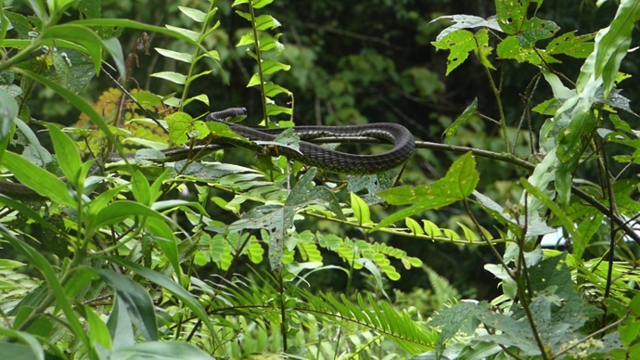
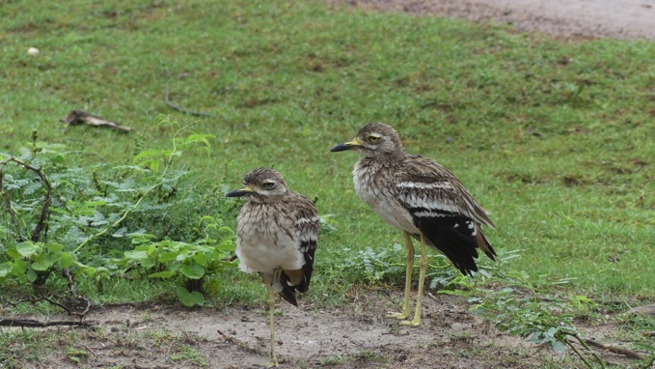
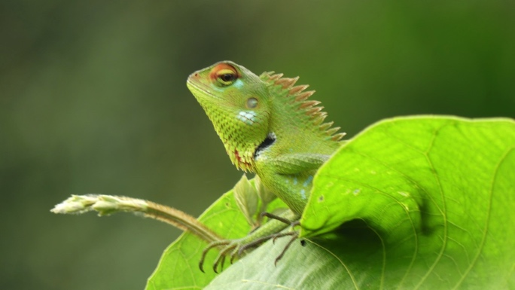

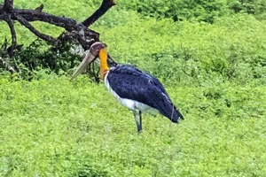
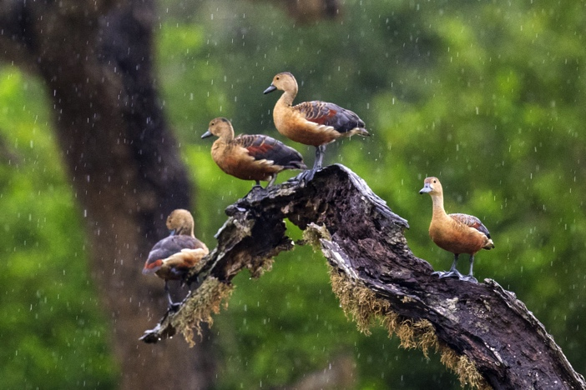
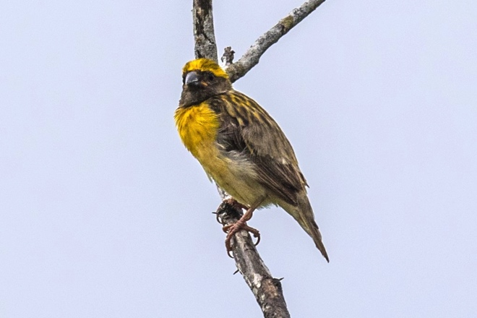

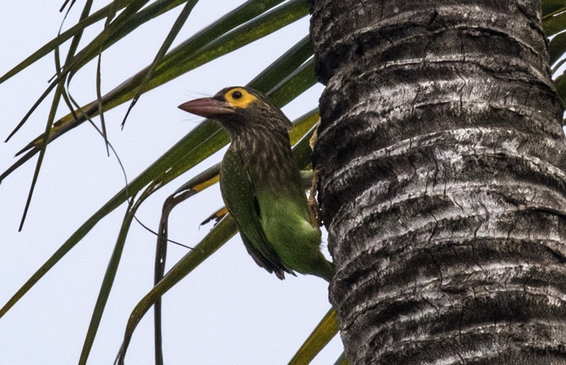
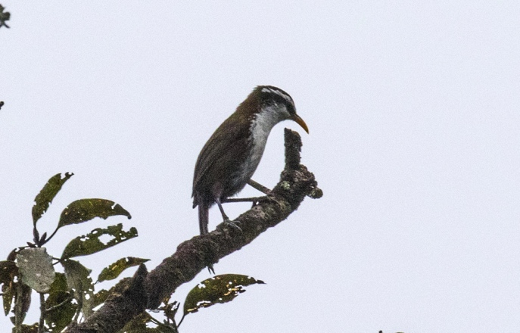
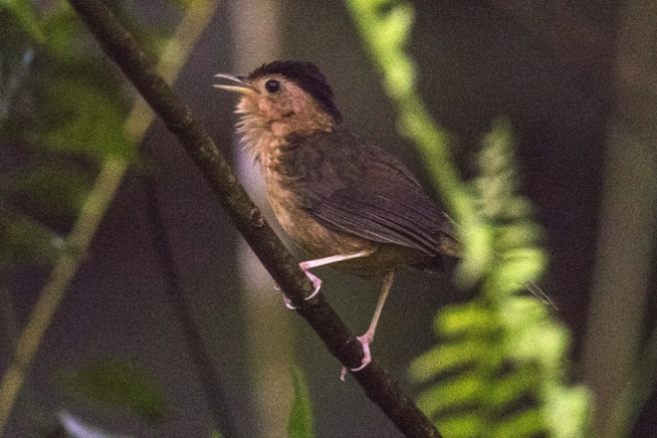

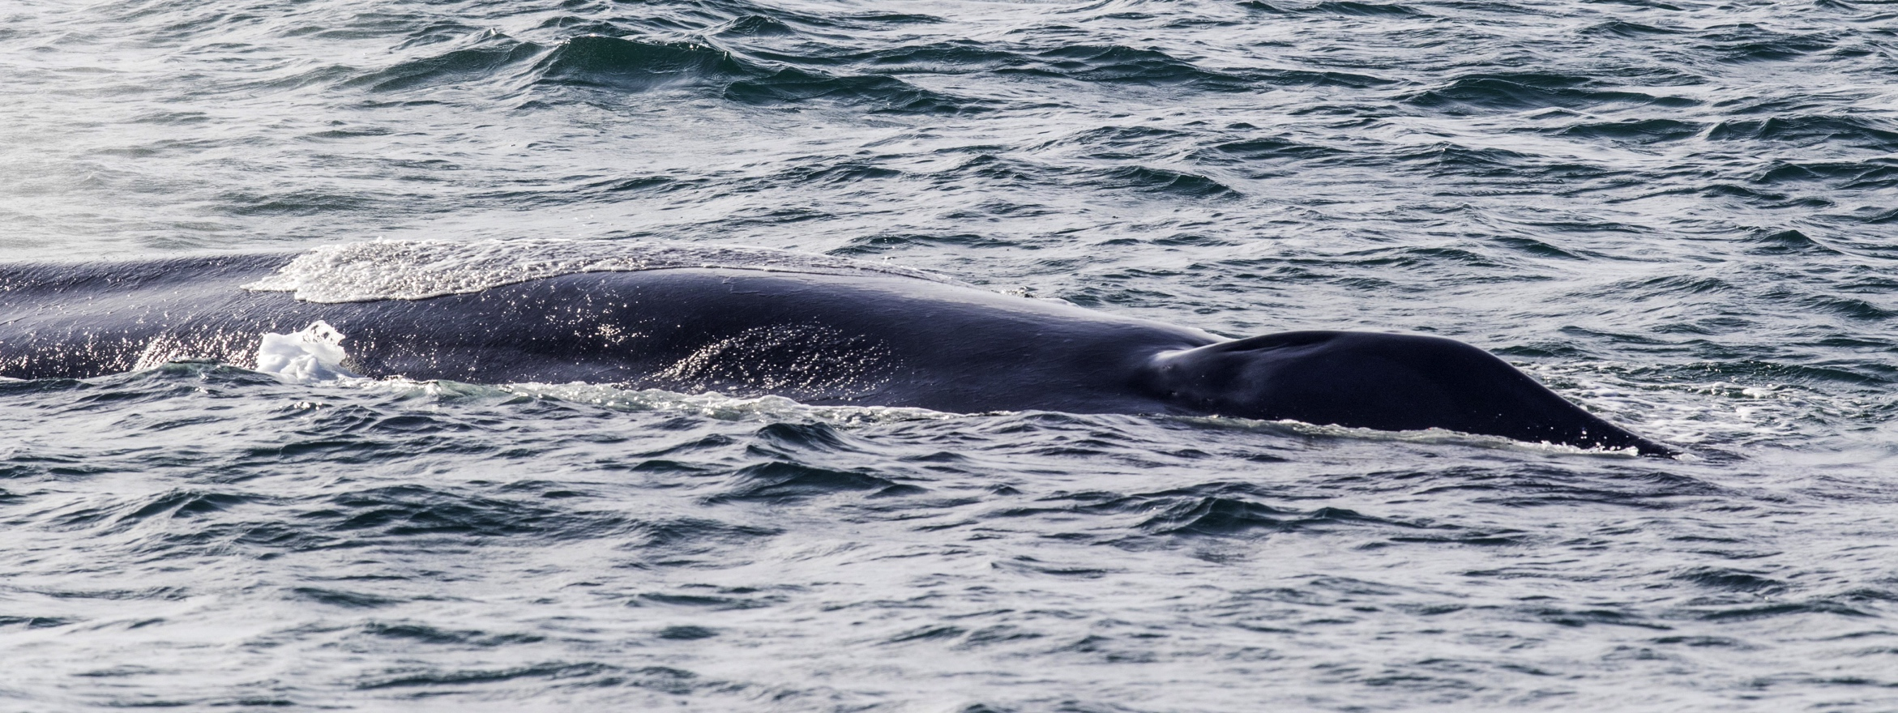

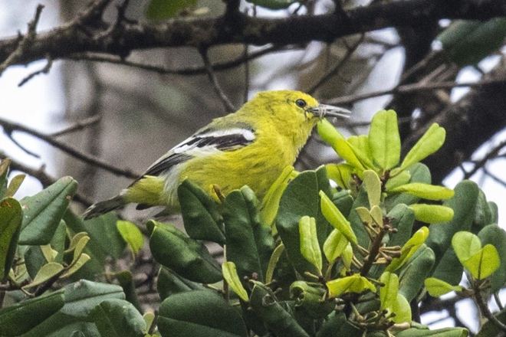
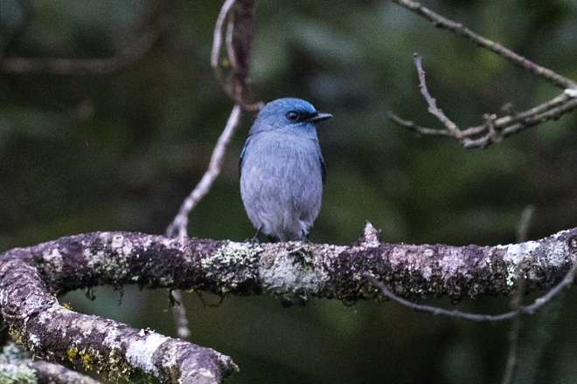
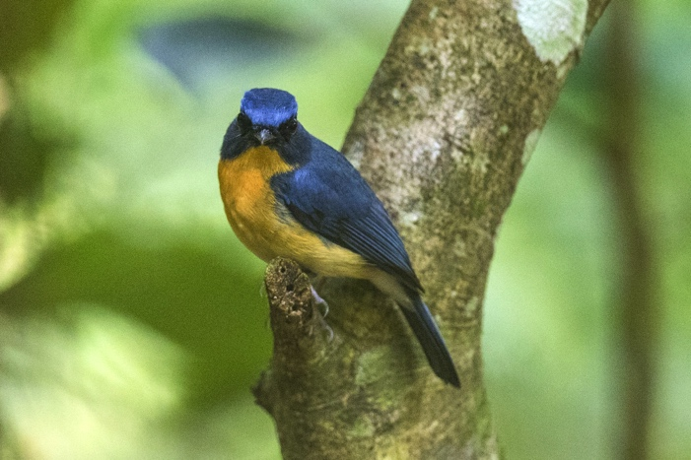

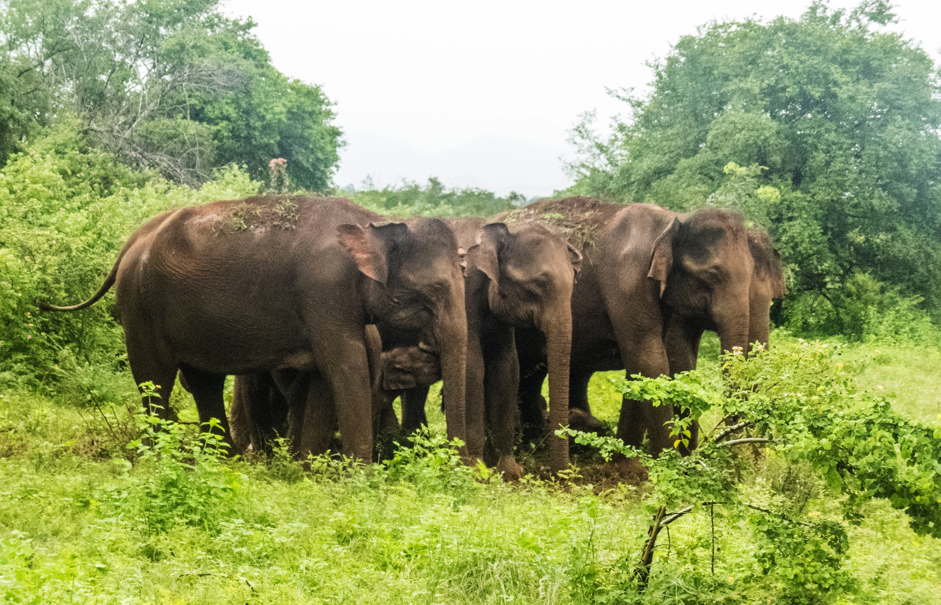

This checklist includes all bird species found in Sri Lanka , based on the best information available at this time. It is based on a wide variety of sources that I collated over many years. I am pleased to offer these checklists as a service to birdwatchers. If you find any error, please do not hesitate to report them.

The taxonomic order and nomenclature follows Clements, version 2017.

The birds marked in yellow are those which not appear in the”HELM FIELD GUIDES” Birds of Siri Lanka - Deepal Warakagoda. Karol Inskipp. Tim Inskipp. Richard Grimmett

The birds marked in red are the ENDEMIC BIRDS OF SIRI LANKA

Brown Capped Woodpecker – Just recorded by picture, as any of the members of the party saw it but a picture was taken before we could relocalize it
